**Response for Assignment 2.2**

Below screenshot shows the output of the program which creates a specific pattern with *

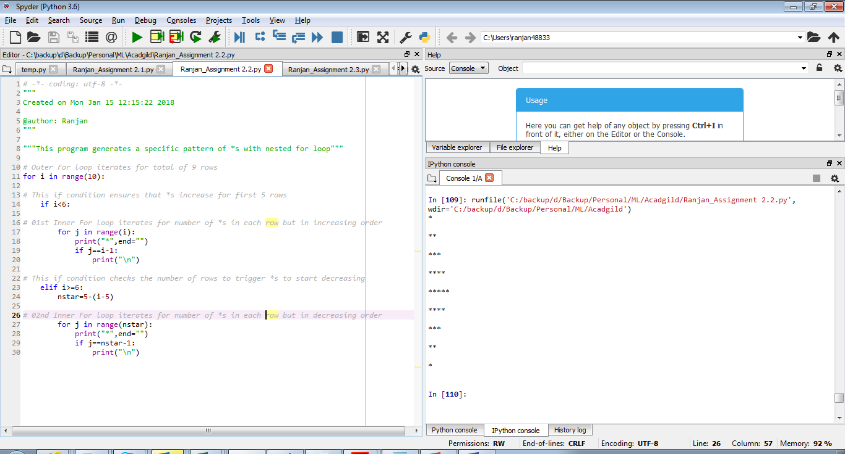

**Below is the source code**

# Outer For loop iterates for total of 9 rows

for i in range(10):

# This if condition ensures that *s increase for first 5 rows

if i<6:

# 01st Inner For loop iterates for number of *s in each row but in increasing order

for j in range(i):

print("*",end="")

if j==i-1:

print("\n")

# This if condition checks the number of rows to trigger *s to start decreasing

elif i>=6:

nstar=5-(i-5)

# 02nd Inner For loop iterates for number of *s in each row but in decreasing order

for j in range(nstar):

print("*",end="")

if j==nstar-1:

print("\n")